**Subject: Student Exchange Programme 2025-26: Main Round Application**

**Student Exchange Programme 2025-26**

**Main Round Application**

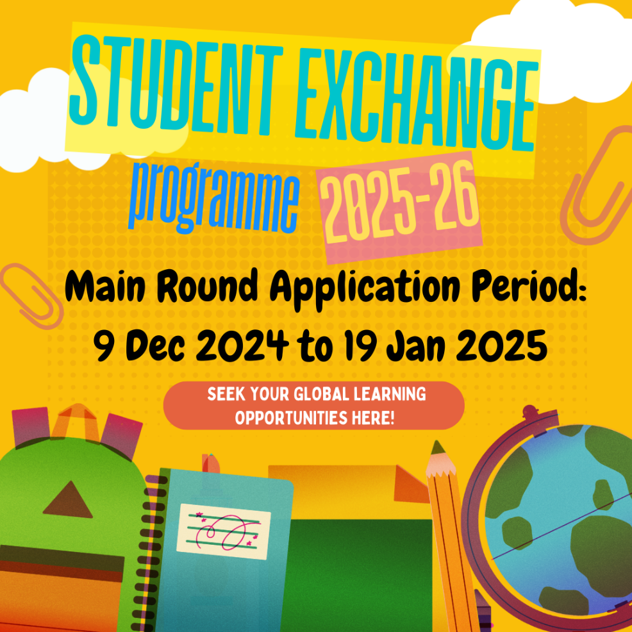

Student Exchange Programme (SEP) offers exchange opportunities in over 40 destinations around the world. The Main Round Application for SEP in 2025-26 will be open from December 9, 2024, to January 19, 2025. Don't miss out on this incredible opportunity.

**Four Wise Steps for an Application**

**STEP 1:** Check the application details on the [Global Engagement Office website](https://www.cityu.edu.hk/geo/global-opportunities/student-exchange/outbound-student-exchange/application)

**STEP 2:** Get your English Language results ready

**STEP 3:** Consult with your academic advisor or [exchange coordinator](https://www.cityu.edu.hk/geo/global-opportunities/student-exchange/outbound-student-exchange/resources-enquiry) on your study plan

**STEP 4:** Submit your application on AIMS under the Student Services section > Outbound Student Exchange Application

**Seek Your Global Learning Opportunities Here!**